[![Review Assignment Due Date](https://classroom.github.com/assets/deadline-readme-button-22041afd0340ce965d47ae6ef1cefeee28c7c493a6346c4f15d667ab976d596c.svg)](https://classroom.github.com/a/XoLGRbHq)

[![Open in Visual Studio Code](https://classroom.github.com/assets/open-in-vscode-2e0aaae1b6195c2367325f4f02e2d04e9abb55f0b24a779b69b11b9e10269abc.svg)](https://classroom.github.com/online_ide?assignment_repo_id=15280404&assignment_repo_type=AssignmentRepo)

# SE-Assignment-5

Installation and Navigation of Visual Studio Code (VS Code)

Instructions:

Answer the following questions based on your understanding of the installation and navigation of Visual Studio Code (VS Code). Provide detailed explanations and examples where appropriate.

Questions:

1. Installation of VS Code:

- Describe the steps to download and install Visual Studio Code on Windows 11 operating system. Include any prerequisites that might be needed.

* 1. Download the Installer:[**https://code.visualstudio.com/Download**](https://code.visualstudio.com/Download)
* Go to the Visual Studio Code download page
* Click on the "Windows" download link to get the installer.

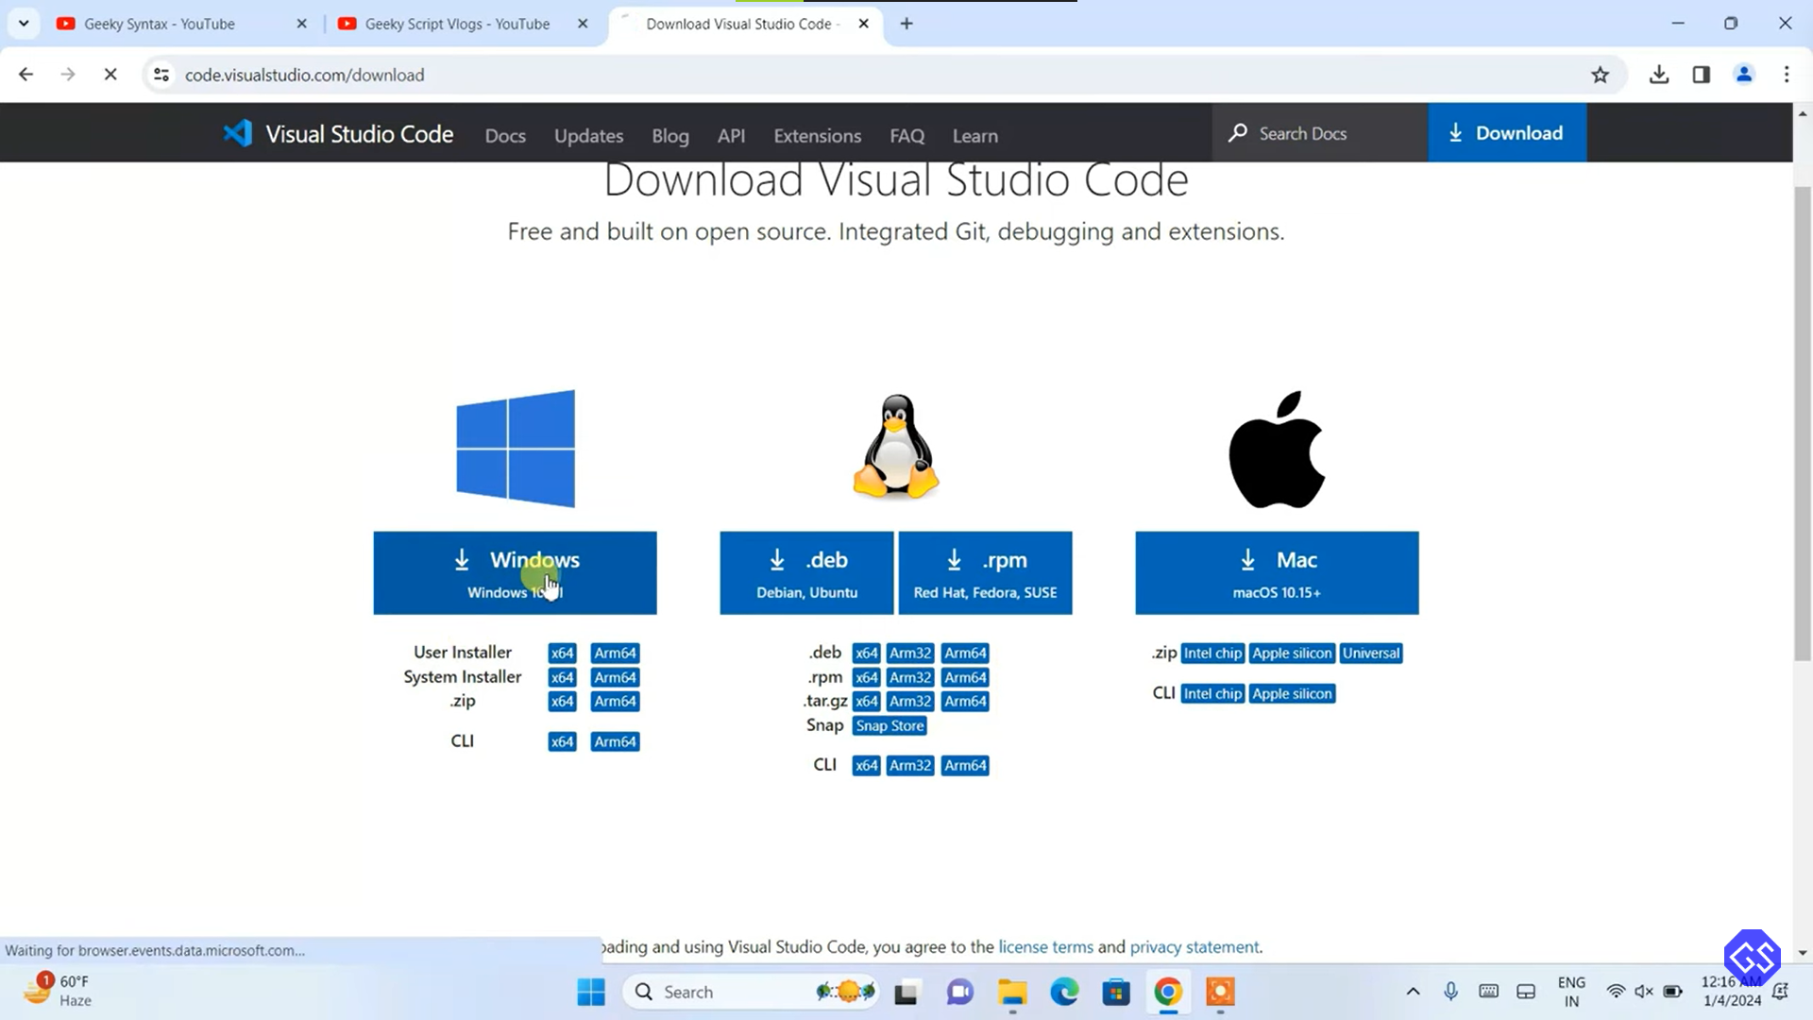

2. Run the Installer:

* Once the download is complete, locate the installer file (VSCodeSetup.exe) in your Downloads folder and double-click it to run.

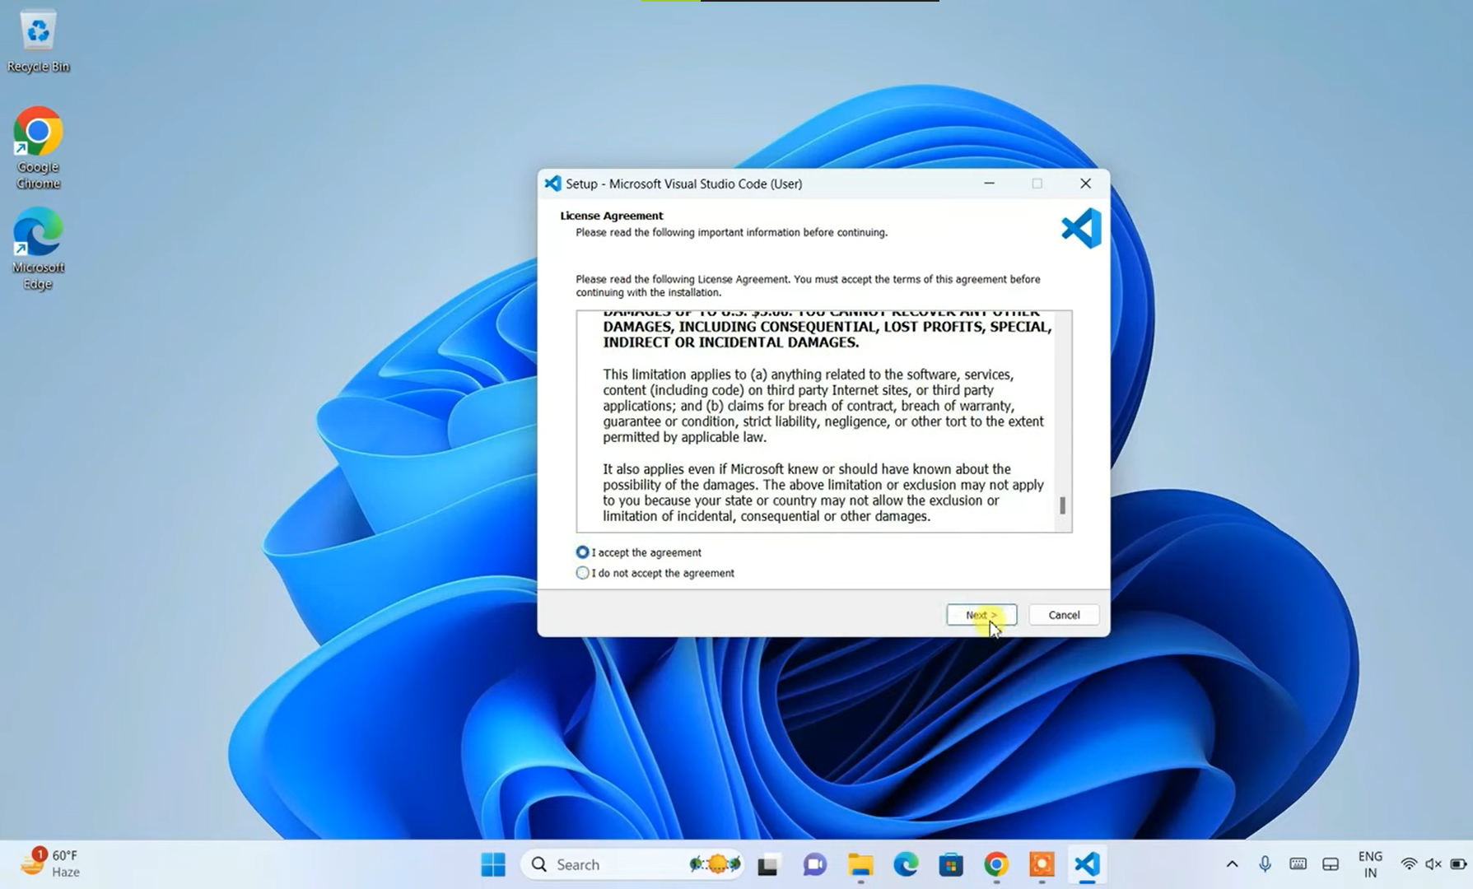

* 3. Follow the Installation Wizard:
* - You will be greeted by the installation wizard. Click "Next" to proceed through the steps.
* - Accept the License Agreement: Read the license terms and click "I accept the agreement," then click "Next."
* - Select Destination Location: Choose the folder where you want to install VS Code or leave it at the default location. Click "Next."

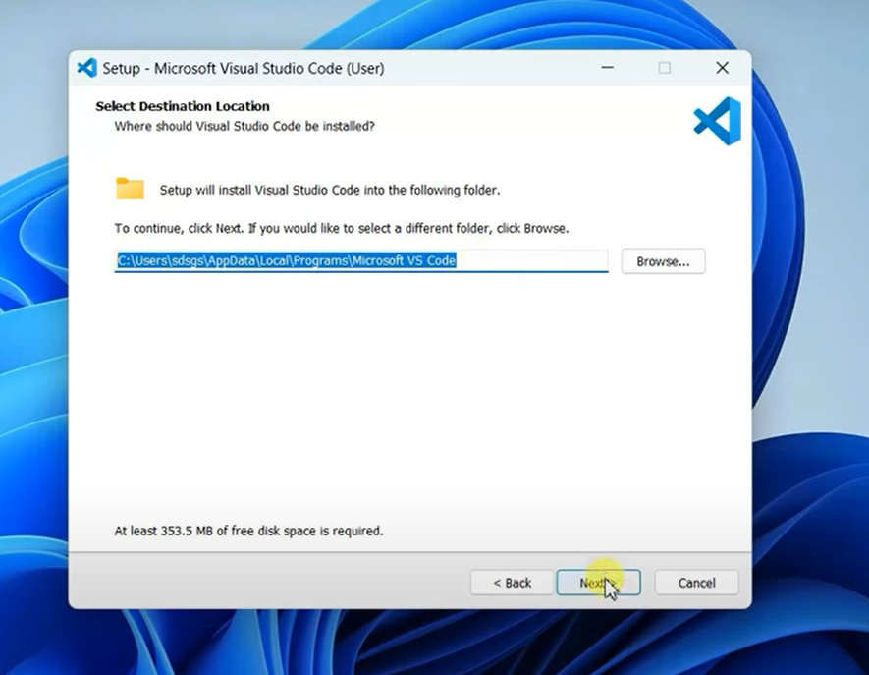

* Select Additional Tasks: Here, you can choose to:
* Create a desktop icon.
* Add "Open with Code" actions to the Windows Explorer context menu.
* Add "Open with Code" actions to the Windows Explorer directory context menu.
* Register Code as an editor for supported file types.
* Add to PATH (this allows you to open VS Code from the command line).
* 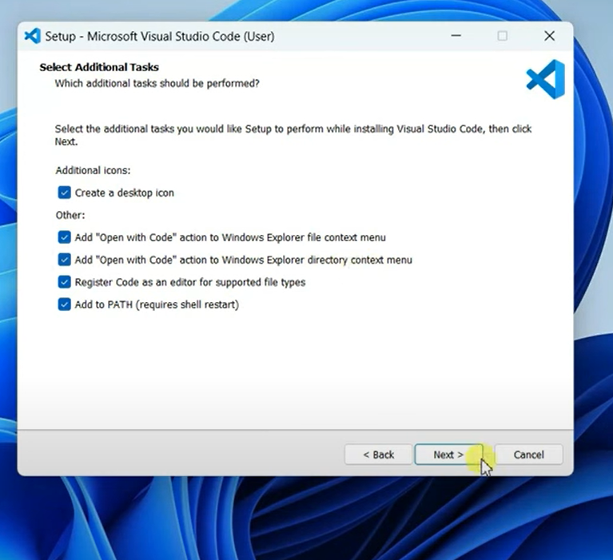
* Select the options you prefer and click "Next."
* 4. Install Visual Studio Code:
* Click the "Install" button to start the installation process. This may take a few moments.

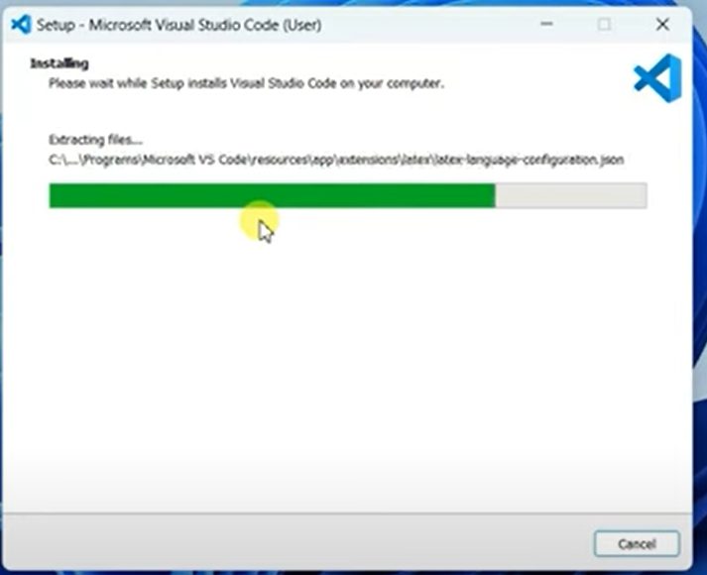

* 5. Launch Visual Studio Code:
* Once the installation is complete, you can choose to launch VS Code immediately by checking the "Launch Visual Studio Code" box and clicking "Finish."
* Alternatively, you can start VS Code later by finding it in the Start menu or using the desktop icon if you created one.

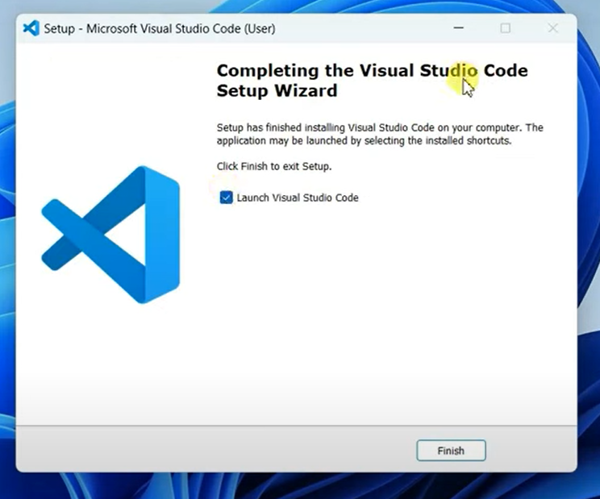

6. Set Up VS Code:

* When you first launch VS Code, you might be prompted to customize your settings and install recommended extensions.

2. First-time Setup:

After installing VS Code, what initial configurations and settings should be adjusted for an optimal coding environment? Mention any important settings or extensions.

* **Welcome Screen:** Upon launching VS Code for the first time, you'll see the Welcome Screen. You can explore tutorials, create a new file, or open an existing folder.

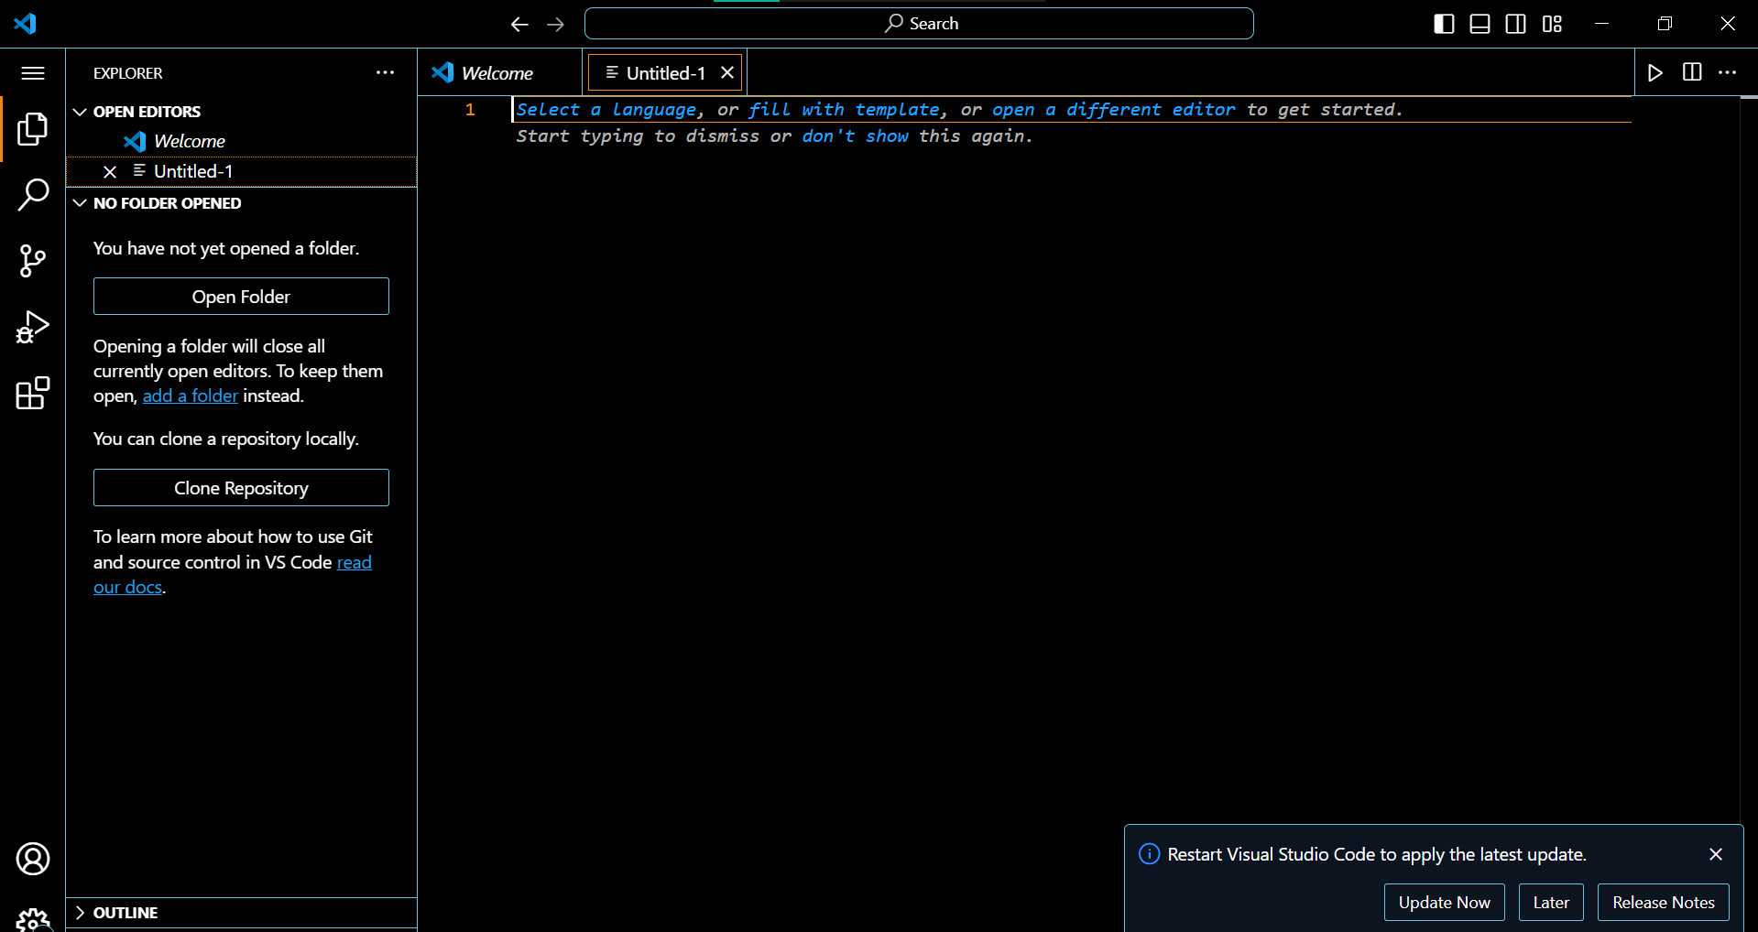

* **Recommended Settings:**
  + **Themes:** Choose a theme that suits your preference (dark themes are generally easier on the eyes for extended coding sessions). Go to **File > Preferences > Settings (or Code > Preferences > Settings on macOS)** (**Ctrl+,** or **Cmd,**) to explore themes.

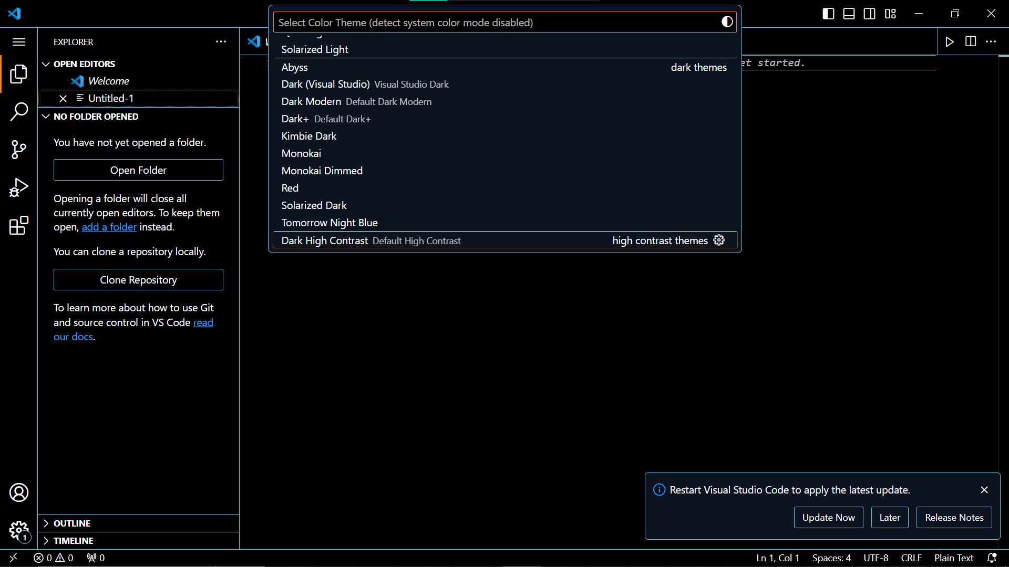

* + **Extensions:** Install extensions for language support (e.g., Python, JavaScript), debugging tools, and productivity enhancements (like code linters and formatters). See section 5 for details.

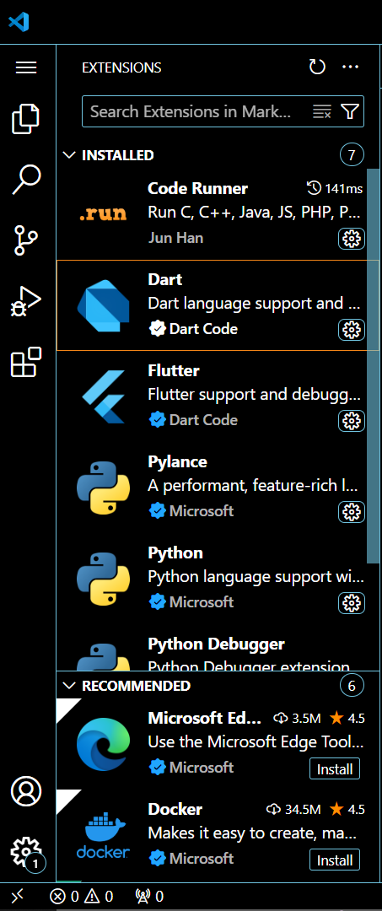

* + **Font Size:** Adjust the font size for better readability (**File > Preferences > Settings** or **Code > Preferences > Settings**).
* **Initial Project Setup:** If you're opening an existing project, make sure VS Code detects the correct language and provides relevant features.

3. User Interface Overview:

Explain the main components of the VS Code user interface. Identify and describe the purpose of the Activity Bar, Side Bar, Editor Group, and Status Bar.

* **Activity Bar (leftmost panel):** Provides access to common views like the Explorer (file management), Search, Source Control (Git), Extensions, and the integrated terminal. You can customize the order and visibility of icons.
* **Side Bar (next to Activity Bar):** Displays the currently opened files and folders, a search bar, and specific views based on the active panel (e.g., Git status in Source Control).
* **Editor Group (center area):** Holds the files you're working on. You can open multiple files and arrange them in tabs or split views (**View > Split Editor**).
* **Status Bar (bottom):** Shows information about the current file (language, line number, column), indentation mode, and active terminal session.

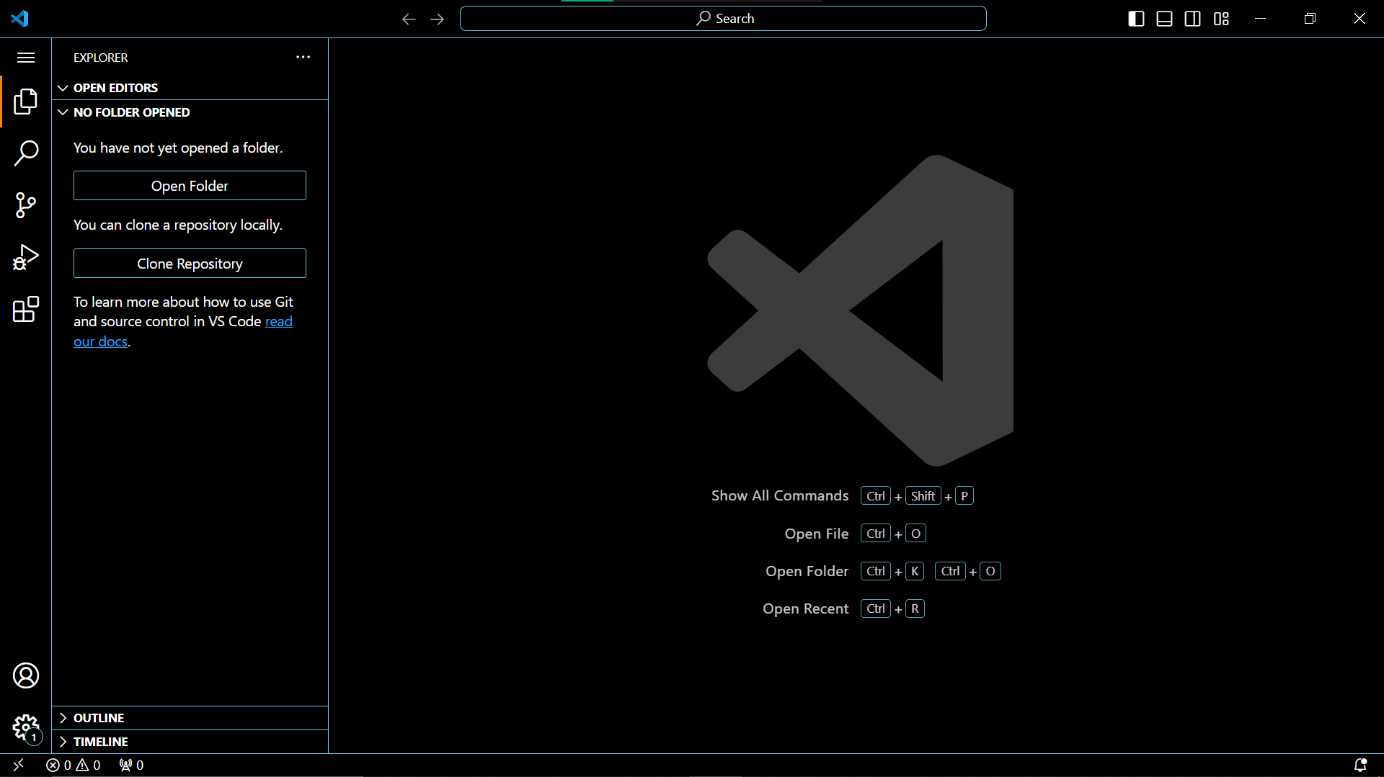

4. Command Palette:

What is the Command Palette in VS Code, and how can it be accessed? Provide examples of common tasks that can be performed using the Command Palette.

• **What it is:** A powerful tool to access all VS Code commands and settings quickly via a searchable interface.

• **Access:** Open it with **Ctrl+Shift+P (Windows/Linux)** or **Cmd+Shift+P (macOS)**. Type keywords to find commands or settings.

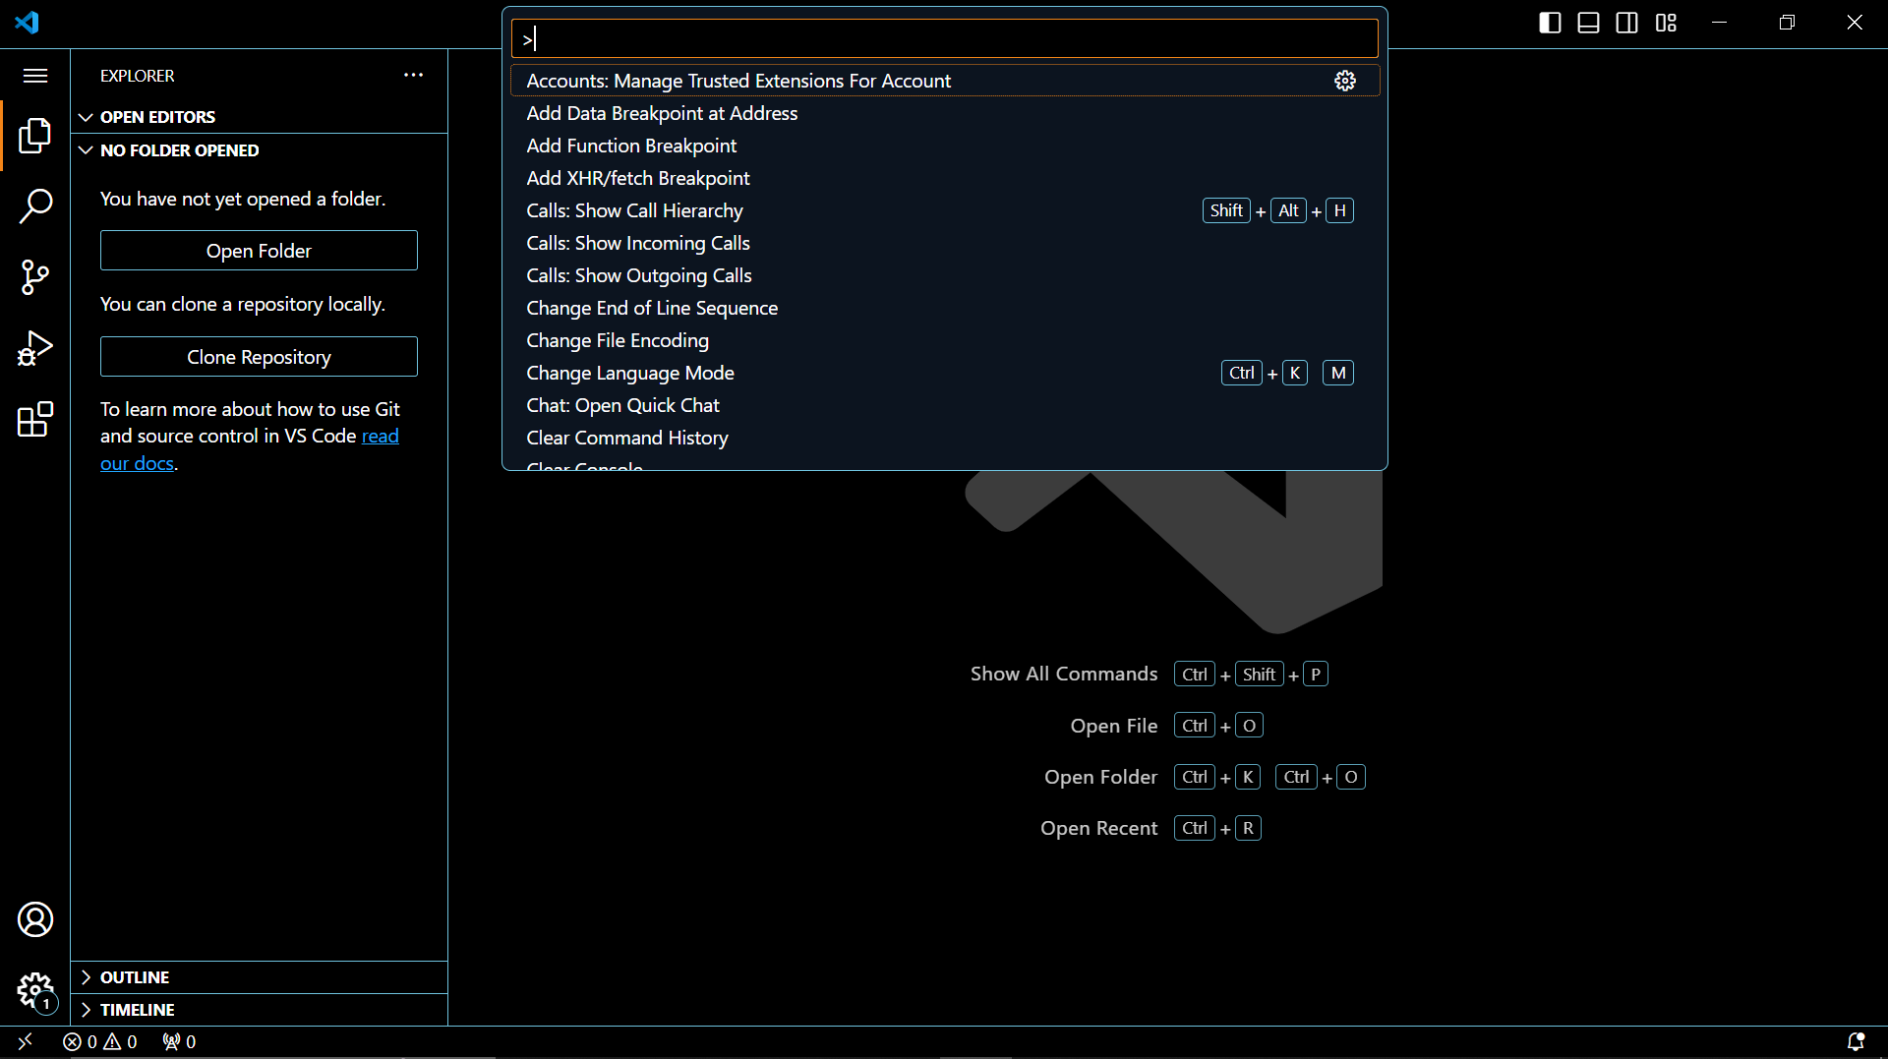

• **Examples:**

* Create a new file: "New File"
* Open a folder: "Open Folder"
* Show keyboard shortcuts: "Keyboard Shortcuts"
* Change settings (e.g., theme): Type "theme" and select the desired option

5. Extensions in VS Code:

Discuss the role of extensions in VS Code. How can users find, install, and manage extensions? Provide examples of essential extensions for web development.

• **Role:** Extensions enhance VS Code's functionality with language support, debugging tools, productivity aids, linters, formatters, and more.

• **Find, Install, and Manage:**

1. Open the Extensions view (**Ctrl+Shift+X** or **Cmd+Shift+X**).
2. Browse or search for extensions.
3. Click the "Install" button for the desired extension.
4. Manage extensions under the Extensions view (enable/disable, uninstall).

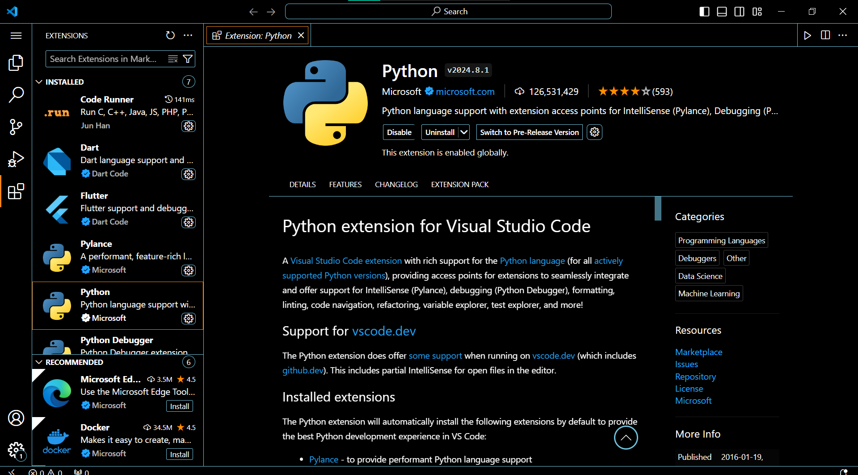

• **Essential Extensions (Web Development):**

* Python: For Python development
* JavaScript (ESLint): Linting and code quality checks for JavaScript projects
* Live Server: Launches a local development server for previewing web pages
* Bracket Pair Colorizer: Improves code readability by colorizing matching brackets

6. Integrated Terminal:

Describe how to open and use the integrated terminal in VS Code. What are the advantages of using the integrated terminal compared to an external terminal?

• **Open:** Go to **Terminal > New Terminal** (**Ctrl+** or **Cmd+**) or use the Command Palette ("New Terminal").

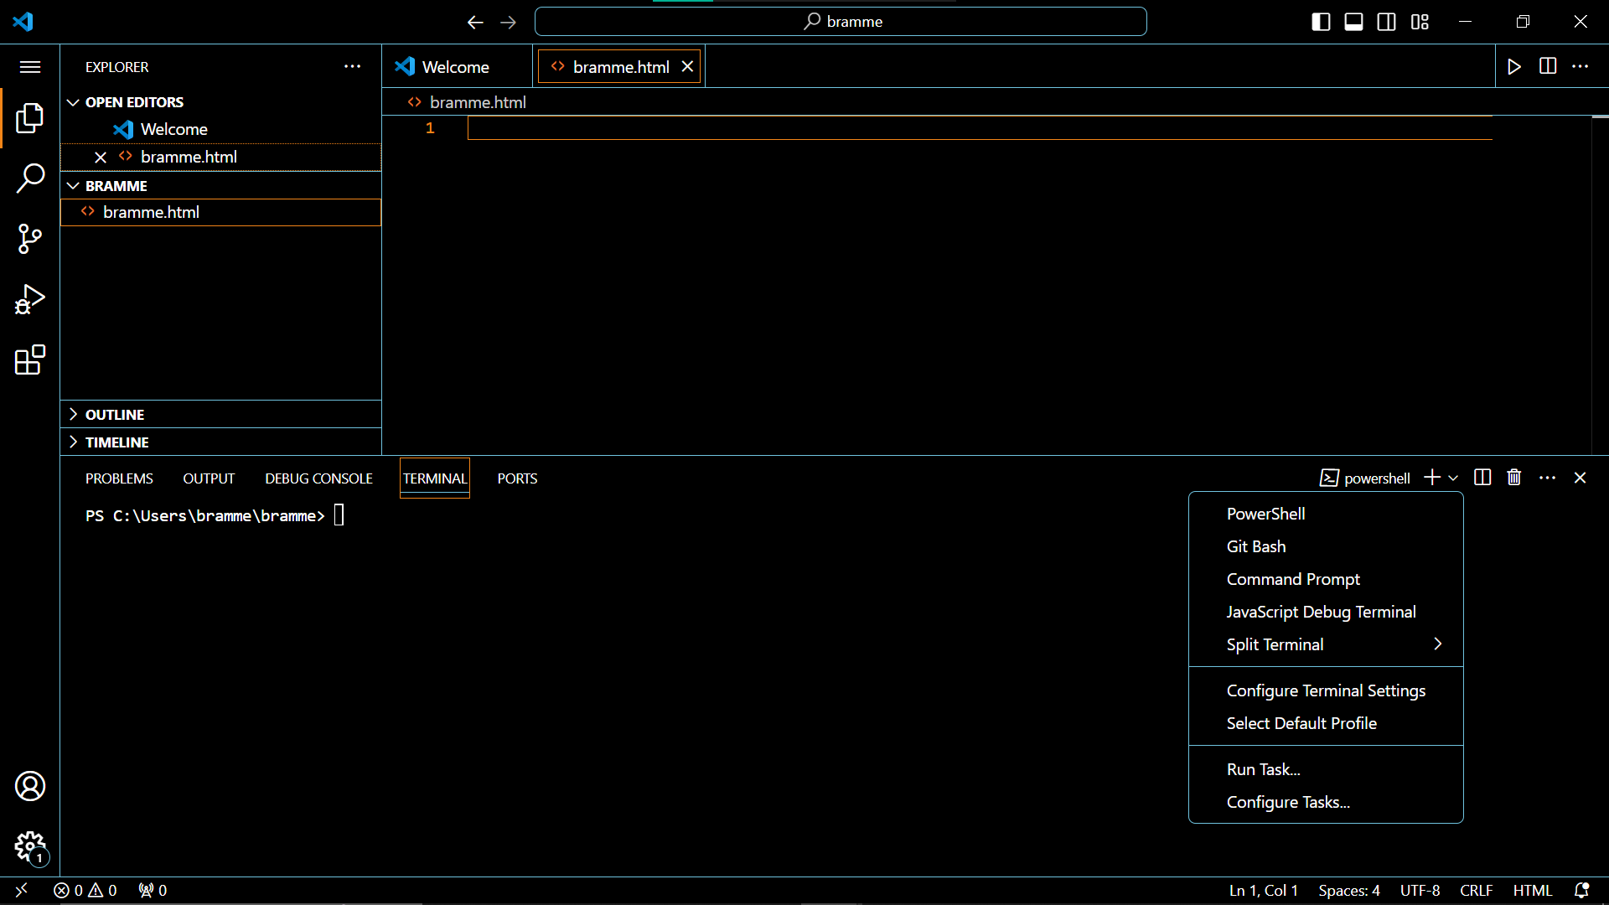

• **Advantages:**

* Seamless integration with VS Code: Run commands, debug your code, and manage Git repositories directly from VS Code.
* Multiple terminals: Open multiple terminal sessions for different tasks.
* Customization: Adjust settings like shell type, font size, and colors.

• **Comparison with External Terminal:** More convenient for working within your coding environment, reducing context switching.

7. File and Folder Management:

- Explain how to create, open, and manage files and folders in VS Code. How can users navigate between different files and directories efficiently?

• **Manage Files:**

* Right-click on a file for options like rename, copy, delete, and cut.
* Use the Command Palette for rename, move, and other actions.

• **Navigate Efficiently:**

* Use the Explorer: Browse through folders and files, double-click to open.
* Breadcrumbs: Shows the current file path, click segments to navigate up.
* Go to File: Quickly jump to specific files using the "Go to File" command (**Ctrl+G** or **Cmd+G**).

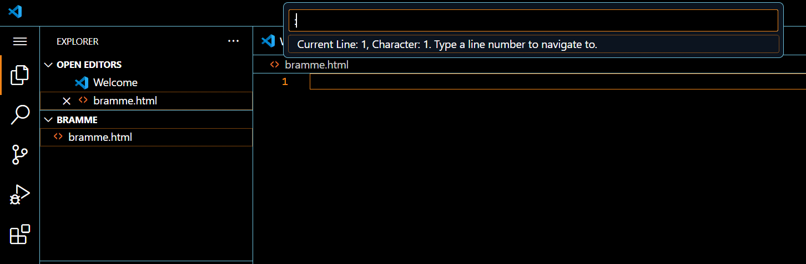

* Open Recent: Access recently opened files from the File menu.
* Keyboard shortcuts: Learn keyboard shortcuts for common actions (like "Ctrl+W" to close the current file).

8. Settings and Preferences:

Where can users find and customize settings in VS Code? Provide examples of how to change the theme, font size, and keybindings.

• **Location:**

* Go to **File > Preferences > Settings (or Code > Preferences > Settings on macOS)** (**Ctrl+,** or **Cmd,**).
* Alternatively, open the Command Palette ("Preferences: Open Settings").

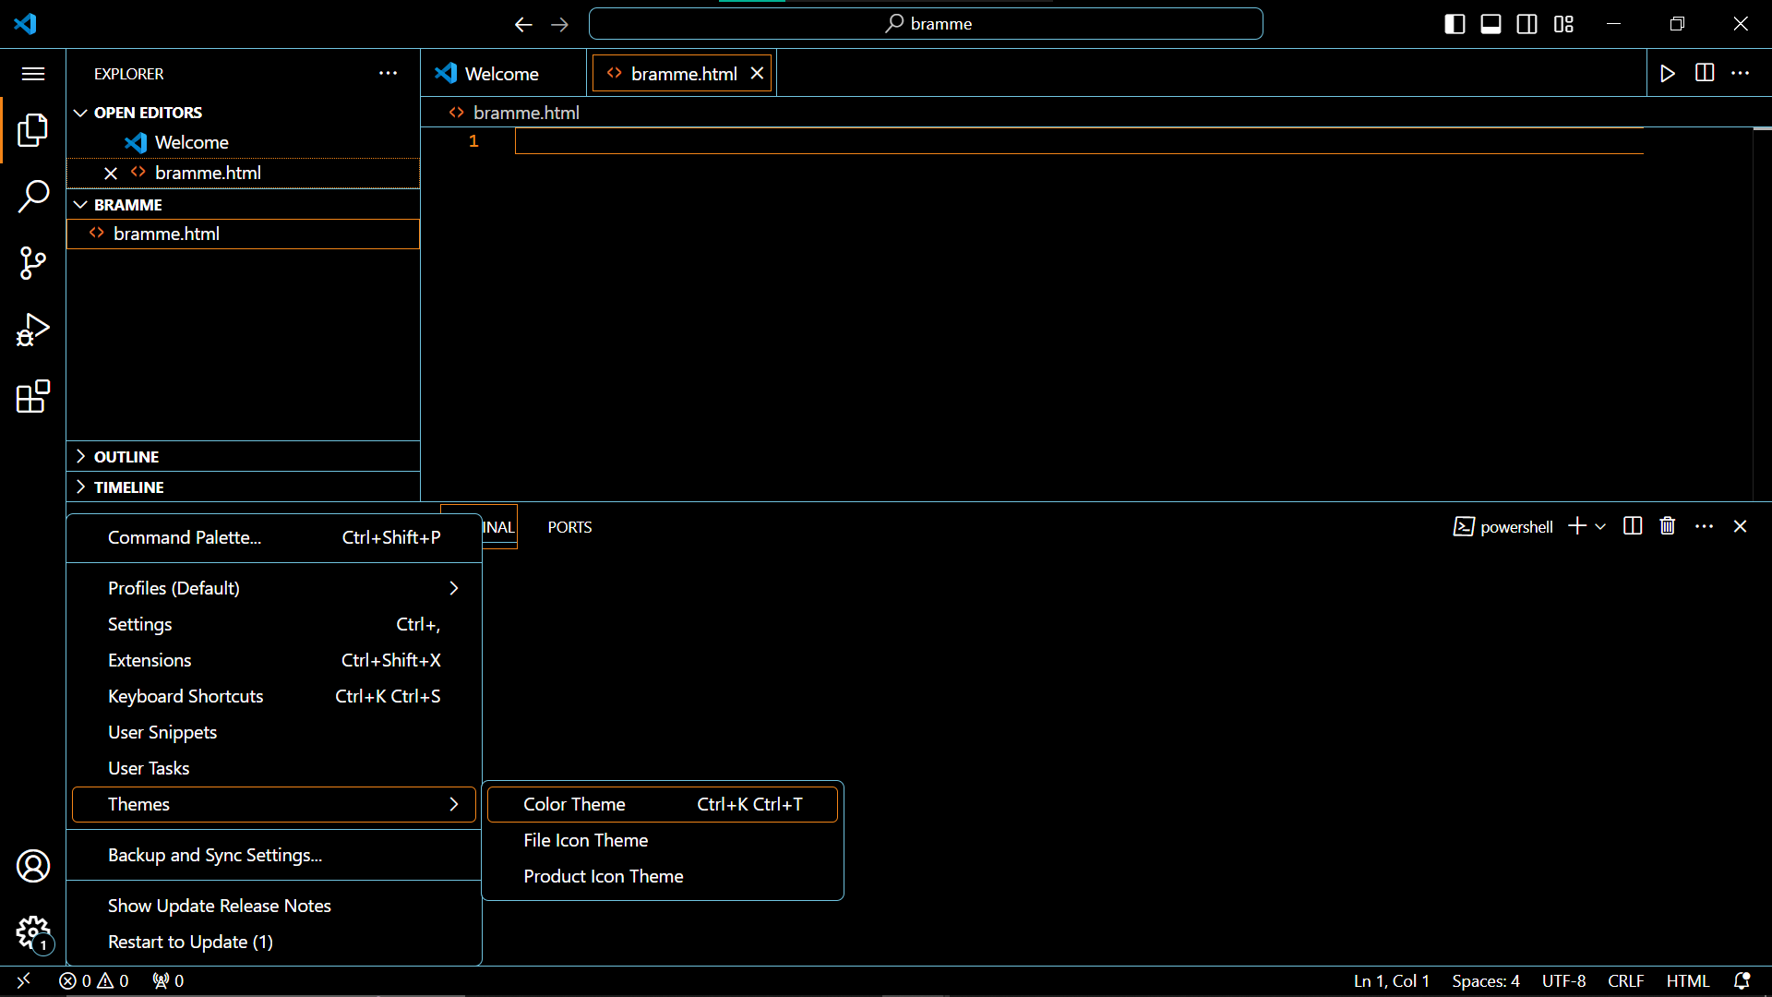

• **Customization Examples:**

* **Theme:** Search for "Theme" and select your preferred theme (e.g., "Dark+ Default").
* **Font Size:** Search for "Font Size" and adjust the editor font size.
* **Keybindings:** Search for "Keyboard Shortcuts" to view existing keybindings and customize them (JSON editing skills recommended).

9. Debugging in VS Code:

Outline the steps to set up and start debugging a simple program in VS Code. What are some key debugging features available in VS Code?

**Steps:**

1. **Install Language Debugger Extension:** Ensure the extension for your programming language (e.g., Python debugger for Python) is installed.
2. **Create Launch Configuration:** Go to **Run and Debug** view (**Ctrl+Shift+D** or **Cmd+Shift+D**), select "create a launch.json file". Choose a template for your language.

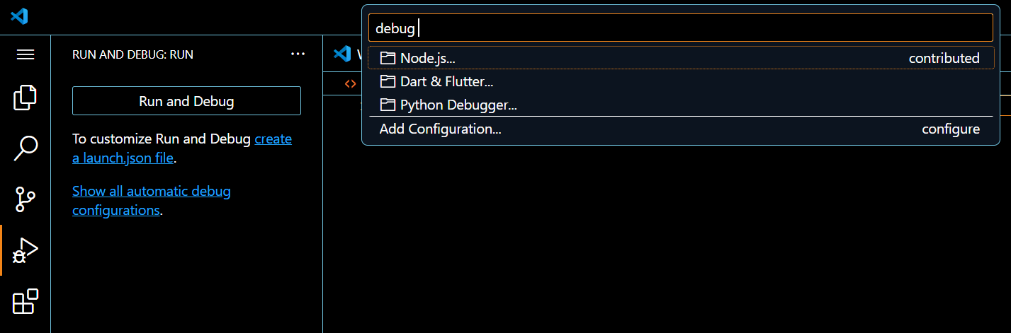

1. **Configure Launch Configuration:** Edit the launch.json file (usually in the .vscode folder) to specify your program's entry point and debugging options.

To set up debugging, click on the gear icon in the bottom left corner of the VS Code window and select "Debug: Open Configuration (JSON)".

In the debug configuration file, add the following lines to configure the debugger:

json

{

"name": ".vscode/launch.json",

"version": "0.2.0",

"configurations": [

{

"name": ".vscode/launch.json",

"type": "node",

"request": "launch",

"program": "${file}",

"sourceFileMap": {

"${file}": "${file}"

},

"outFiles": [],

"sourceRoot": "${workspaceFolder}/src"

}

]

}

Save the changes and close the debug configuration file.

**Key Debugging Features:**

* **Breakpoints:** Pause execution at specific lines.
* **Call Stack:** See the sequence of function calls leading to the current line.
* **Variables:** Inspect the values of variables at breakpoints.
* **Step Over/Step Into/Step Out:** Control program execution line by line.
* **Console:** Interact with your program using the integrated terminal.

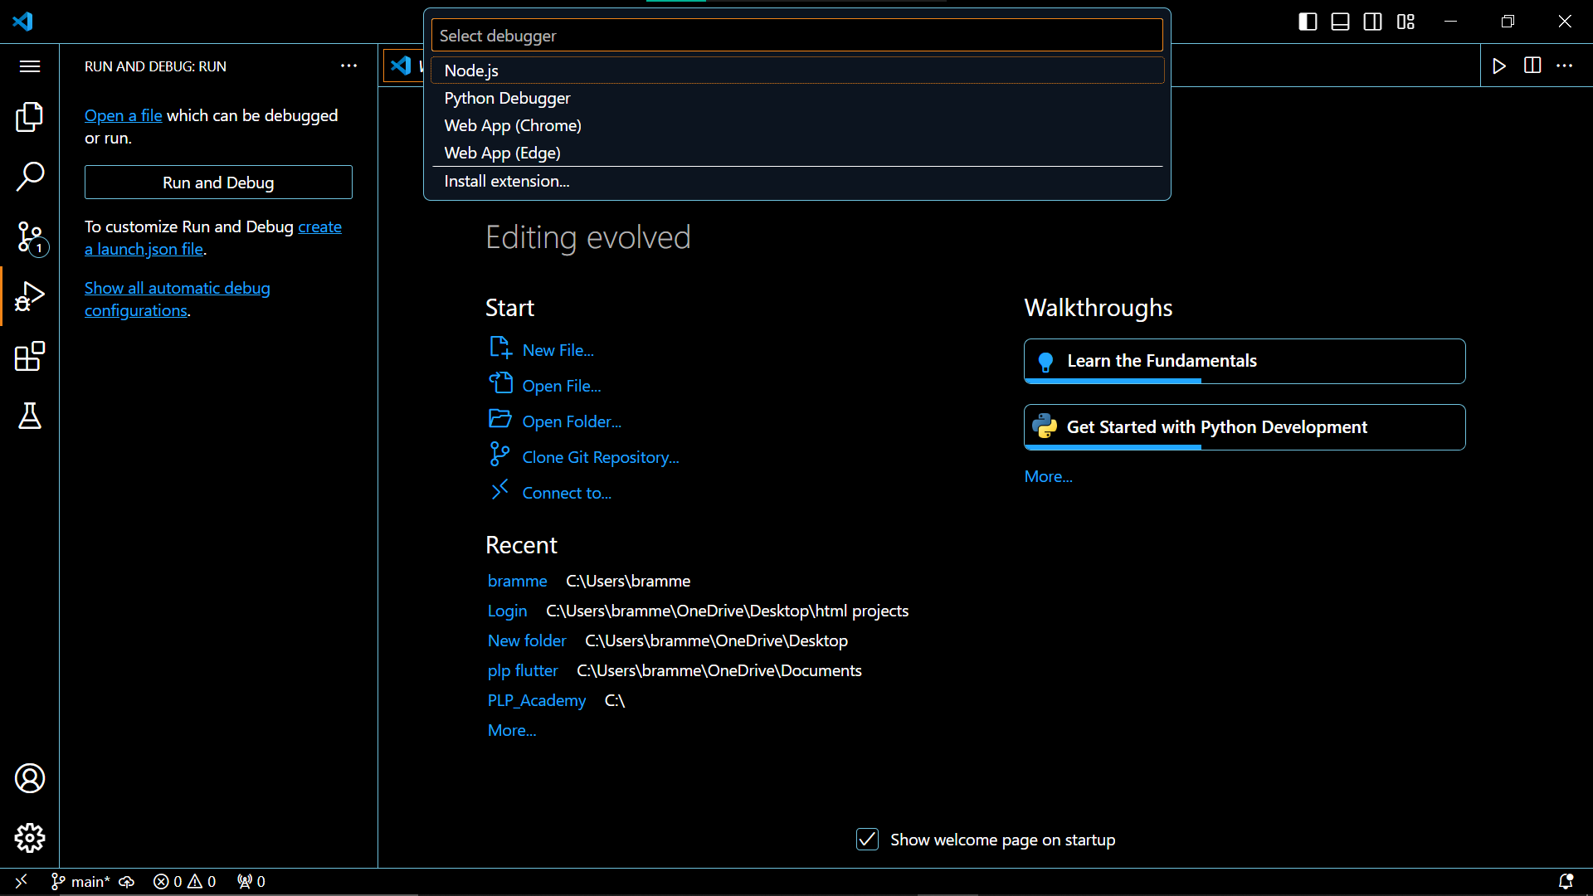

**10. Using Source Control (Git) with VS Code:**

**Integration:**

1. **Install Git:** Download and install Git from the official Git website (<https://www.git-scm.com/downloads>).
2. **VS Code Integration:** No additional configuration is usually needed.

**Workflow:**

1. **Initialize Repository:** Open the Command Palette and search for "Git: Initialize Repository". This creates a .git folder in your project for version control.
2. **Make Changes:** Edit your files as usual.
3. **Stage Changes (optional):** Use the Source Control view to "stage" specific changes before committing.
4. **Commit Changes:** Enter a meaningful commit message and use the Source Control view to commit changes. This creates a snapshot of your project at that point.
5. **Push to GitHub:** Create a remote repository on GitHub and use the Source Control view to push your local commits to the remote repository.

**Benefits:**

* Version control: Track changes over time and revert to previous versions if needed.
* Collaboration: Work with others on the same project and manage code changes.
* Remote storage: Backup your project code on GitHub.

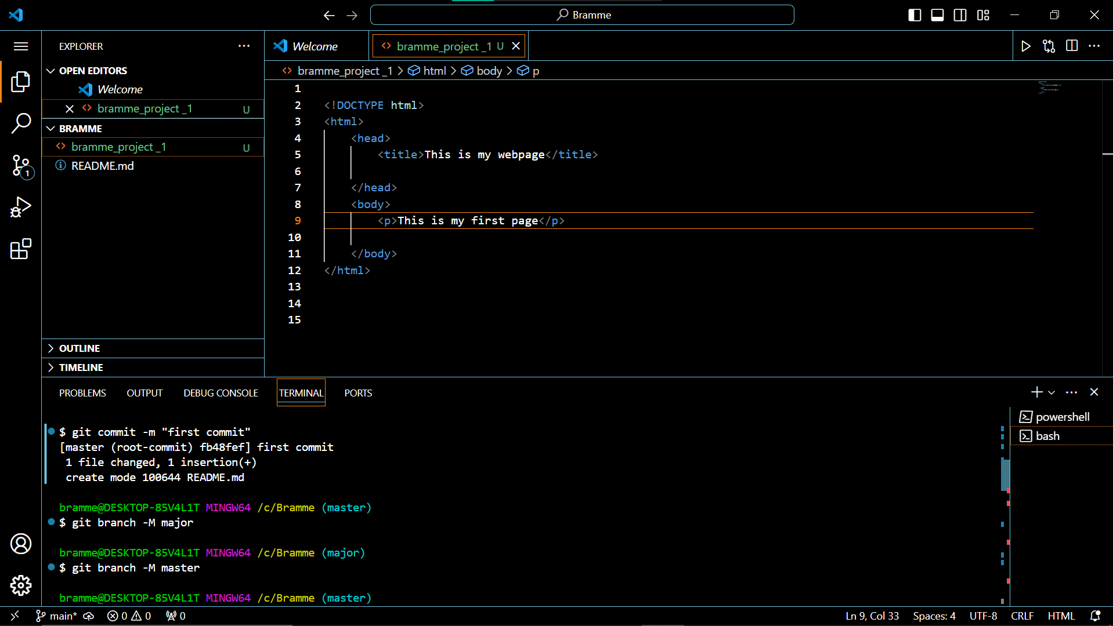

Submission Guidelines:

- Your answers should be well-structured, concise, and to the point.

- Provide screenshots or step-by-step instructions where applicable.

- Cite any references or sources you use in your answers.

- Submit your completed assignment by 1st July